Difference between Supervised and Unsupervised Learning
Supervised and Unsupervised learning are the two techniques of machine learning. But both the techniques are used in different scenarios and with different datasets. Below the explanation of both learning methods along with their difference table is given.
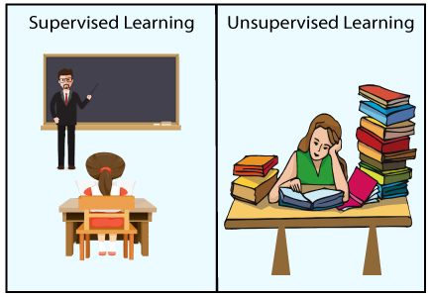
Supervised Machine Learning:
Supervised learning is a machine learning method in which models are trained using labelled data. In supervised learning, models need to find the mapping function to map the input variable (X) with the output variable (Y).
Supervised learning needs supervision to train the model, which is similar to as a student learns things in the presence of a teacher. Supervised learning can be used for two types of problems: Classification and Regression.
Example: Suppose we have an image of different types of fruits. The task of our supervised learning model is to identify the fruits and classify them accordingly. So to identify the image in supervised learning, we will give the input data as well as output for that, which means we will train the model by the shape, size, color, and taste of each fruit. Once the training is completed, we will test the model by giving the new set of fruit. The model will identify the fruit and predict the output using a suitable algorithm.

Example 2
Scenario: Image Classification of Animals
Imagine we are building a machine learning model to automatically identify different types of animals in photos. To accomplish this, we need to train the model with examples, where each example consists of an input (an image) and a corresponding output label (the type of animal in that image).
Step-by-Step Explanation:
- Data Collection:
  - We gather a large dataset of images, each containing one type of animal such as cats, dogs, and birds.
  - Each image is accompanied by a label indicating the correct category (e.g., "Cat," "Dog," "Bird").
- Labeling the Data:
  - Each image in our dataset is manually labeled. For example:
    - Image 1: A photo of a cat → Label: "Cat"
    - Image 2: A photo of a dog → Label: "Dog"
    - Image 3: A photo of a bird → Label: "Bird"
  - This labeled data serves as the "ground truth," meaning the correct answer for what is present in each image.
- Data Preparation:
  - Before feeding the images into the model, we preprocess them. This might include resizing the images to a standard size, normalizing pixel values, or augmenting the images (e.g., flipping, rotating) to create more examples and make the model robust to variations.
- Training the Model:
  - The model is provided with the input images and their corresponding labels. During training:
    - The model learns to recognize patterns and features in the images (such as the shape of ears, fur texture, or the presence of a beak) that correspond to the different labels.
  - The model adjusts its internal parameters through multiple iterations to minimize the error between its predictions and the true labels.
- Model Evaluation:
  - After training, the model is tested on a separate set of images that it has never seen before (called a "validation set" or "test set").
  - For each test image, the model predicts the label (e.g., "Cat," "Dog," "Bird"), and we compare these predictions to the actual labels to evaluate accuracy.
- Model Usage:
  - Once trained and evaluated, the model can be used to classify new, unseen images of animals.
  - For example, if we provide a new image of a cat to the model, it will analyze the image's features and predict "Cat" as the output.
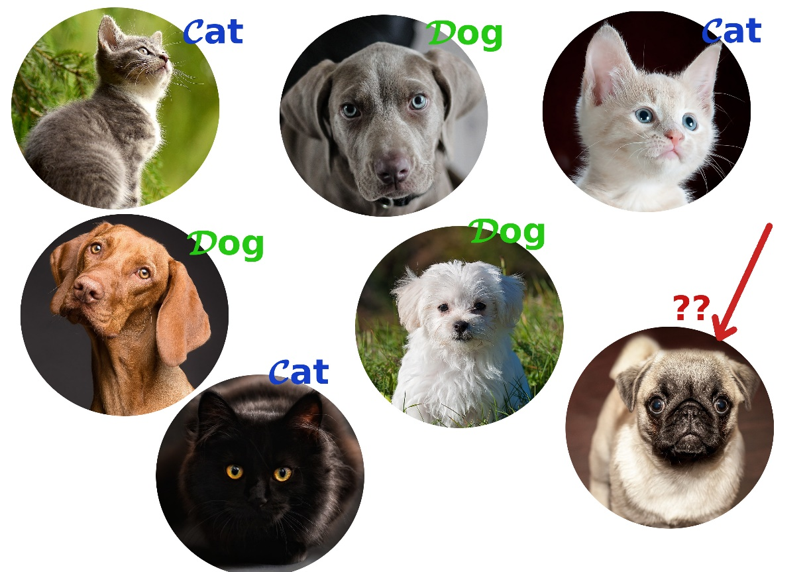

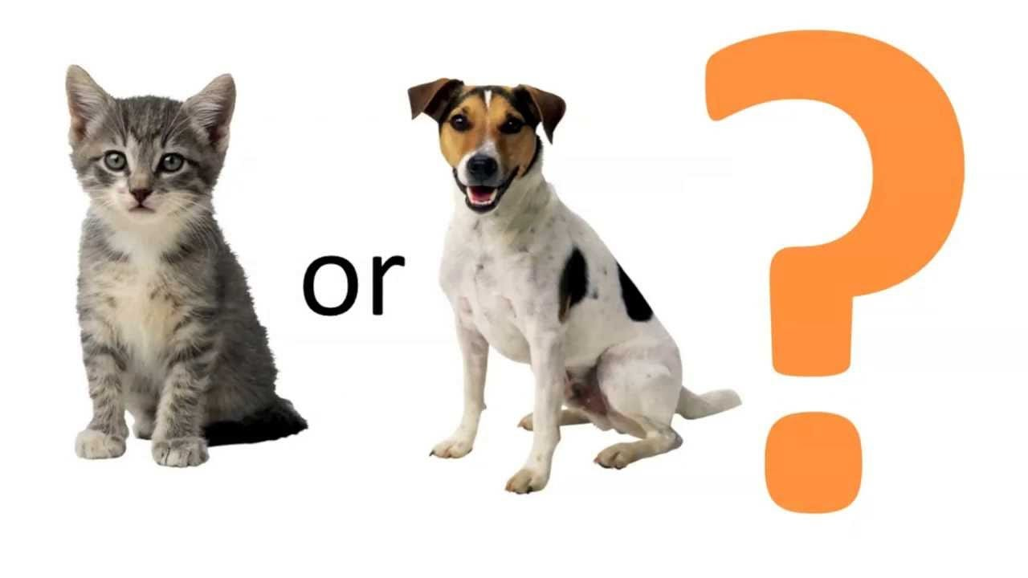

Unsupervised Machine Learning:
Unsupervised learning is another machine learning method in which patterns inferred from the unlabelled input data. The goal of unsupervised learning is to find the structure and patterns from the input data. Unsupervised learning does not need any supervision. Instead, it finds patterns from the data by its own.
Unsupervised learning can be used for two types of problems: Clustering and Association.
Example: To understand the unsupervised learning, we will use the example given above. So unlike supervised learning, here we will not provide any supervision to the model. We will just provide the input dataset to the model and allow the model to find the patterns from the data. With the help of a suitable algorithm, the model will train itself and divide the fruits into different groups according to the most similar features between them.
Again, suppose there is a basket and it is filled with some fresh fruits. The task is to arrange the same type of fruits in one place. This time there is no information about those fruits beforehand, it’s the first time that the fruits are being seen or discovered So how to group similar fruits without any prior knowledge about them? First, any physical characteristic of a particular fruit is selected. Suppose colour. Then the fruits are arranged based on the color.
The groups will be something as shown below:
- RED COLOR GROUP: apples & cherry fruits.
- GREEN COLOR GROUP: bananas & grapes. So now, take another physical character say, size, so now the groups will be something like this.
- RED COLOR AND BIG SIZE: apple.
- RED COLOR AND SMALL SIZE: cherry fruits.
- GREEN COLOR AND BIG SIZE: bananas.
- GREEN COLOR AND SMALL SIZE: grapes

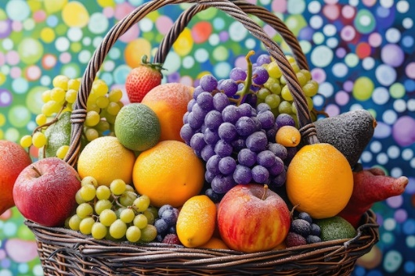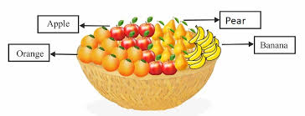

The main differences between Supervised and Unsupervised learning are given below:
 | Supervised learning | Unsupervised Learning
1 | Supervised learning algorithms are trained using labelled data. | Unsupervised learning algorithms are trained using unlabelled data.
2 | In supervised learning, input data is provided to the model along with the output labels. | In unsupervised learning, only input data is provided to the model.
3 | The goal of supervised learning is to train the model so that it can predict the output when it is given new data. | The goal of unsupervised learning is to find the hidden patterns and useful insights from the unknown dataset.
4 | Typically used for regression (predicting continuous values) and classification (predicting categorical values) problems. | Commonly used for clustering (grouping similar items), association (finding relationships between variables), and dimensionality reduction (reducing the number of variables).
5 | The output is typically a specific prediction or classification based on the labelled data. | The results are generally more exploratory and descriptive.

